# **טכנולוגיות אינטרנט מתקדמות - 61776** ( (WEB**הגשת פרויקט**

1. הציגו רשימת דרישות פונקציונליות ולא פונקציונליות

**FR**

1. Users will have the capability to securely register and authenticate their accounts using a username and password.
   1. The app won't let users sign in without correct and existing user name and password, if a user will not stand up to the request the app will alert.
2. Users will be provided with the functionality to monitor and track their progress within their workout routines.
   1. From the side bar menu of the app the user will be able to enter a screen called "My progression" and look at his progression bar
3. The system will enable users to update their fitness goals and measurements as needed.
   1. From the side bar menu the user can enter his account settings and update his goal and his weight.
4. The platform will incorporate support for social features, enabling users to engage and interact with each other within the community.
   1. From training selection page the user can invite a friend via WhatsApp
5. The system will employ a rewards system to encourage and acknowledge users for their active engagement and accomplishments.
   1. After the user completes 5 workouts the app will motivate him using a reward on his Leadbord, and after 21 workouts the app will reward him with another reward

**NFR**

1) Usability: The user interface should be intuitive and easy to navigate.

2) Maintainability: Write clean, modular, and well-documented code to facilitate future updates and maintenance.

3) Integrability: Seamless integration with third-party services such as WhatsApp for workout invitations.

4) Failure management: Provide informative error messages to users

5) Compatibility: Ensure compatibility with a wide range of devices, operating systems, and screen sizes to maximize accessibility and usability for all users.

ארכיטקטורה מעודכנת של האתר

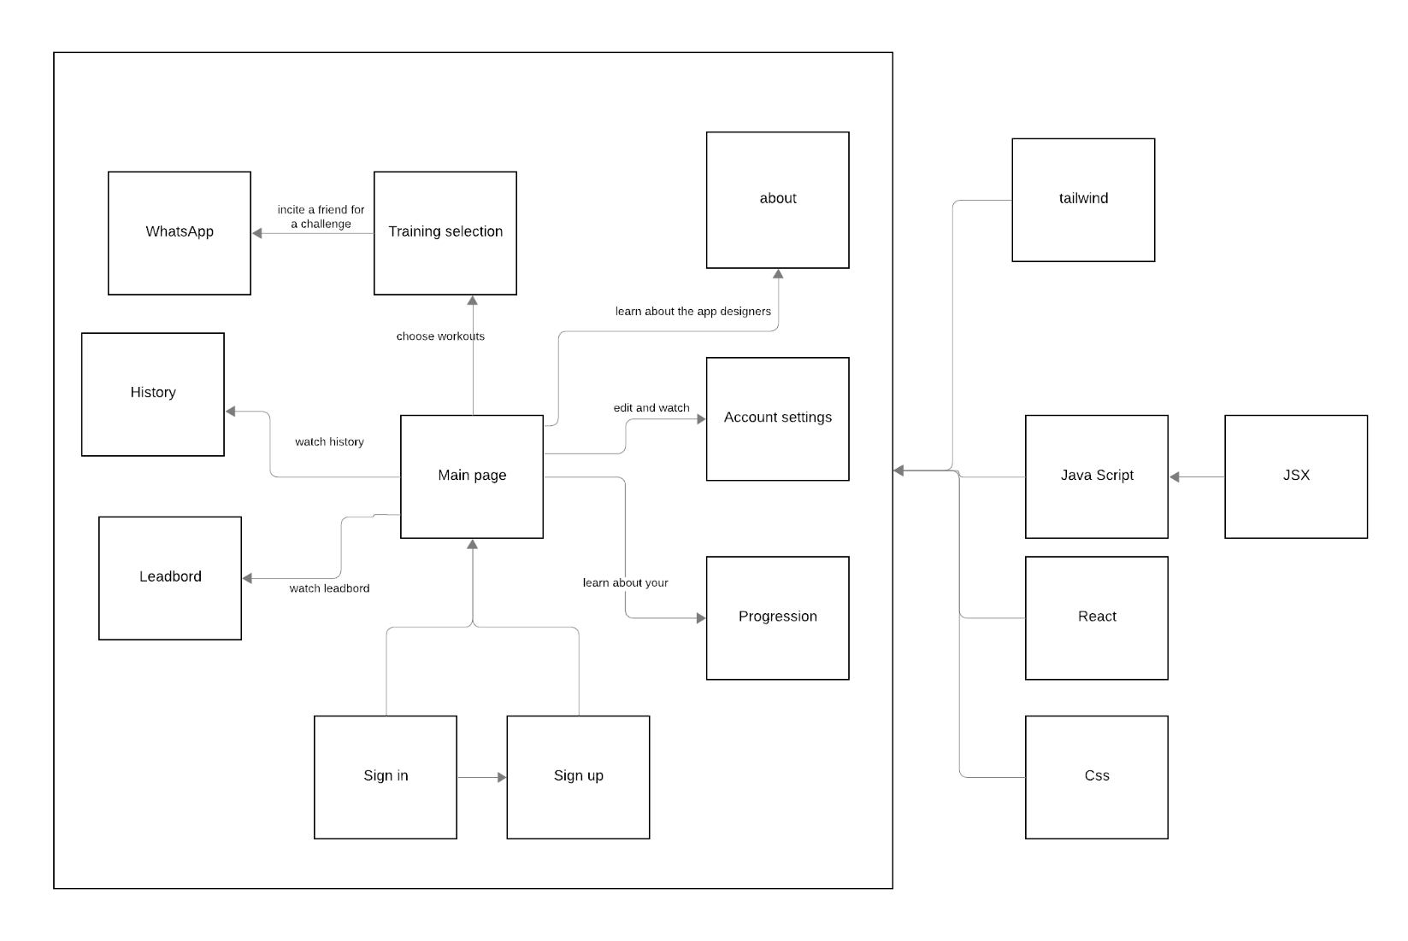 **FRONT END**

**BACK END**

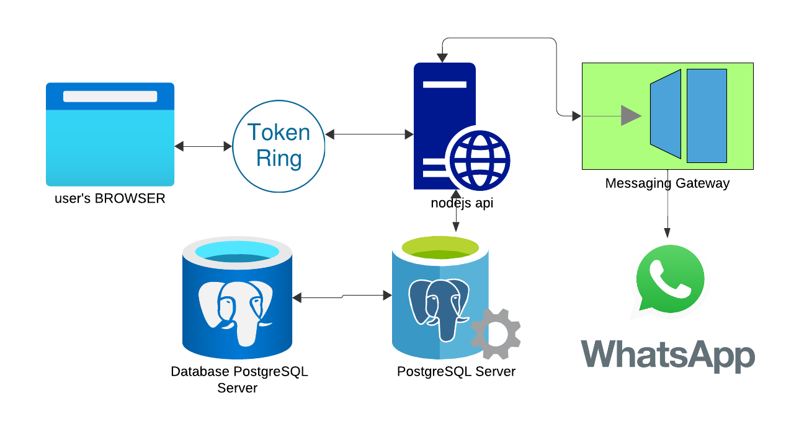

1. דיאגרמת use case :

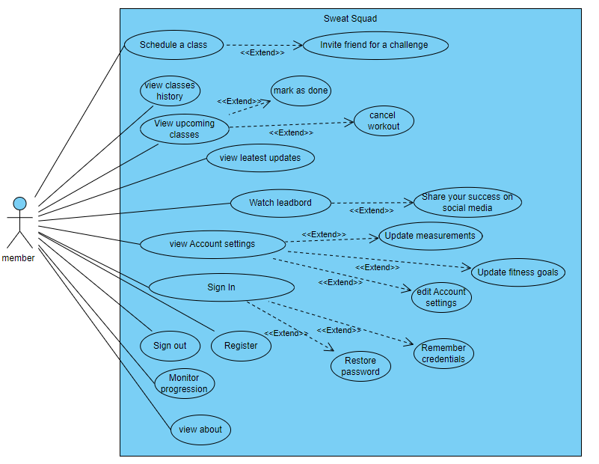

1. 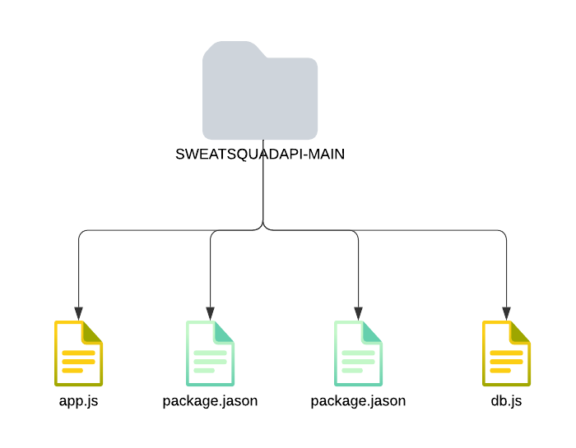מבנה סופי של האתר:   
   א. דיאגרמה המתארת את התיקיות והקבצים השונים.

